NAS EARLYBIRD PLUS  RBK Trainer Team  MARIE DOYLE  ASD Service Co ordinator  JAN CARRATU  Teacher - Sapphire Assessment Resource  Knollmead Primary  SONIA CANDISH  Educational Psychologist  JANE PIDDUCK  Higher Level Teaching Assistant – Grand Avenue Primary  CAROLE COLLINS  Provision Manager, Autism Spectrum Provision  The Mount Primary  CLAIRE COOK  Teacher, ASD Provision - Latchmere School  For details of the next information  meeting and the dates and venue of the next course please contact:  Marie Doyle on 020 8547 6216  (email: marie.doyle@rbk.kingston.gov.uk) |  | 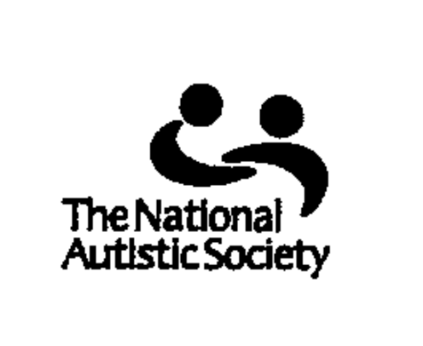  EarlyBird Plus  COURSE FOR PARENTS/CARERS AND PROFESSIONALS WORKING WITH YOUNG CHILDREN (4-8 YEARS) WITH AN AUTISTIC SPECTRUM DISORDER  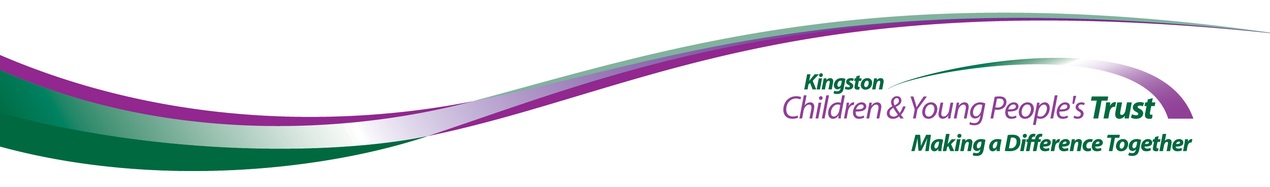
The National Autistic Society (NAS) EarlyBird Plus Programme* is a three month training programme for parents/ carers and professionals working with children 4-8 years with an autistic spectrum disorder.  - It is a three month programme involving up to six families  - It brings together parents/carers and professionals working with the children in school for daytime group training sessions once a week  - It involves families being visited during the programme in their own homes  *EarlyBird Plus is a registered trademark of  The National Autistic Society |  | The NAS EarlyBird Plus Programme works in partnership with parents to help them to:  - Understand their child’s autistic spectrum disorder  - Develop their child’s communication skills  - Develop and apply practical strategies to manage their child’s behaviour  The programme encourages a consistent approach between home and school by training parents and professionals together.

